|  |  |  |
| --- | --- | --- |
| Gears of More | | |
| Game Design Document | | |
|  | | |
| One-button mechanical adventure | | |
|  | | |
|  | | |
| A Mechanical Story, Skyfish Studios.  (Aesthetic reference) | | |
| **Capybara** | | |
| Andre Borja Miranda  Eduardo Cavalcante Almeida  Naomi Freire Nagayama  Sebastian Beltran Convers | | |
|  | | |
|  | | |
|  | Table of Contents  Overview 2  Description 2  Goals 2  Pillars 2  Hook 2  3 Cs 2  Character 2  Camera 2  Controls 2  Features 3  Toothed Surfaces 3  3  Smooth Surfaces 3  Spinners (GTH) 4  Bubble-gum 4  Shredders/Moving Enemies (GTH) 5  Production 6  Kanban Board 6  Team Members and Responsibilities 6  Risks and Mitigation 6  Publishing 6  Art 6  Tech 6  Audio 6  UI 7 |  |

# Overview

## Description

A 2D platformer where the player controls a cog within a machine by pressing a single button.

## Goals

With this game, which is in essence a 2D platformer, the main goal is to explore the different sorts of maps that can be achieved when gravity in itself is a mechanic. We also hope to paint a picture of how that can be done by the implementation of a single button input.

## Pillars

Three pillars that will help inform your design decisions.

1. One Button – the game is supposed to take input from a single button. In our case, that button is ‘Space’ and the action attached to it is jumping.
2. Movement – the character slides through the surfaces at all times and the only player verb is jumping. These are the essential means of traversing through the levels and getting to the objectives.
3. Satisfying – movement in itself is aimed at being satisfying. Jumping from platform to platform, changing directions and collecting keys are all parts of an experience that should be as smooth and endorphin-inducing as possible.

## Hook

This is a 2D platformer with a twist.

# 3 Cs

## Character

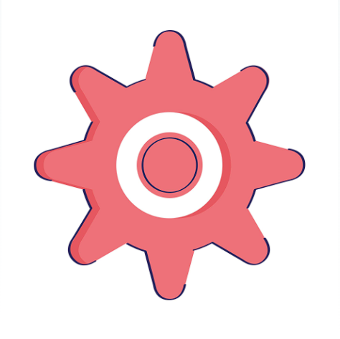A little cog is an essential component of a Robot's heart. The Robot's condition has worsened, and this is due to the irregular amount of bubble gum spread across its surfaces.

Our main character, Coggi, is the only cog whose shape matches the keys needed to unlock the tubes that connect the Robot's organs. Coggi's main mission is to find these keys by spinning through the surfaces, jumping between platforms and inverting the gravity to access different parts of each organ. This will all be done by automatic impulse and the press of a single button: 'Space' to jump.

## Camera

We will use a side-scrolling camera that automatically follows the Cog.

## Controls

Spinning is the essence of the Cog’s movement. Cog spins automatically. Tapping the button makes it jump. The Cog automatically grips to and traverses any toothed surface that is close enough for them to touch.

Gravity inversion is enabled by tapping on buttons that are displayed across the levels, establishing the gravity as Up, Down, Left or Right.

# Features

## Toothed Surfaces

Metallic (brass), shiny, geometric.

On Contact: Cog grips these and spins along their shapes. He travels in the same direction unless he collides with a different object or surface.

## 

## Smooth Surfaces

Clean, Silver or wood shapes.

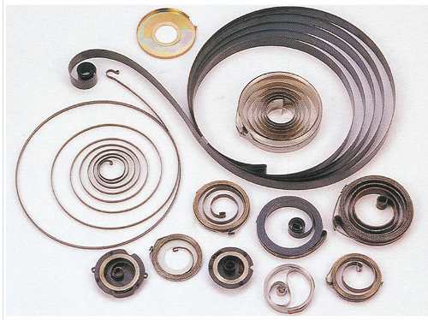On contact: If Cog collides with a flat surface, it bounces off them, reversing directions.

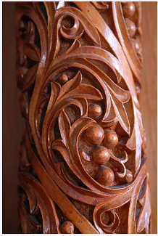

## Spinners (GTH)

A cog-shaped hole or nook that can be used to jump higher than normal.

On contact: Cog fits into it and spins in place.

Tap Button: Cog does a very high jump away from the spinner.

Hold Button: Cog prepares for a very high jump. An arrow indicating the jump trajectory appears and moves back and forth as long as the button is held.

Release Button: Cog jumps very high along the trajectory indicated by the arrow.

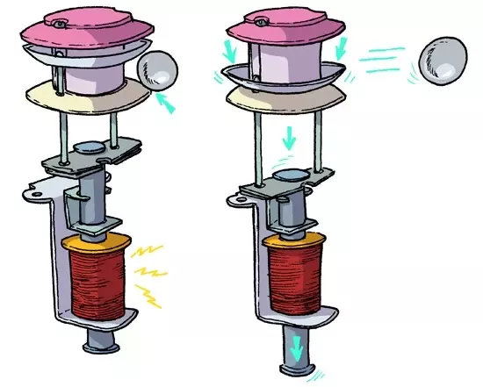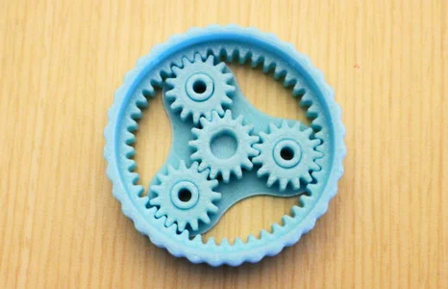

## Bubble-gum

Pieces of pink gunk that are stuck on surfaces and stop Cog’s movement entirely, “killing” him. They are stationary and should be avoided.



# Production

## Kanban Board

Link to the board.

## Team Members and Responsibilities

|  |  |
| --- | --- |
| Team Member | Main Responsibilities |
| Andre Borja Miranda | Programming |
| Eduardo Cavalcante Almeida | Level Design |
| Naomi Freire Nagayama | Project Management, Art |
| Sebastian Beltran | Game Design, Art |

## Risks and Mitigation

Identify any risks and their possible mitigations. Add more rows as needed. Check example below.

|  |  |
| --- | --- |
| Risk | Mitigation(s) |
| Team has never made a game in two weeks | Establish priorities and work with them in mind from the start. Adding details only when prioritized tasks are completed. |
| Team has never made a one-button game | Work to tie all maps together by the use of the one button. |

## Publishing

A link to the itch.io game page.

# Art

Inspired mainly by moving pieces like those seen in watches, clocks and other machinery.

Steampunk elements converted to flat design aesthetic.

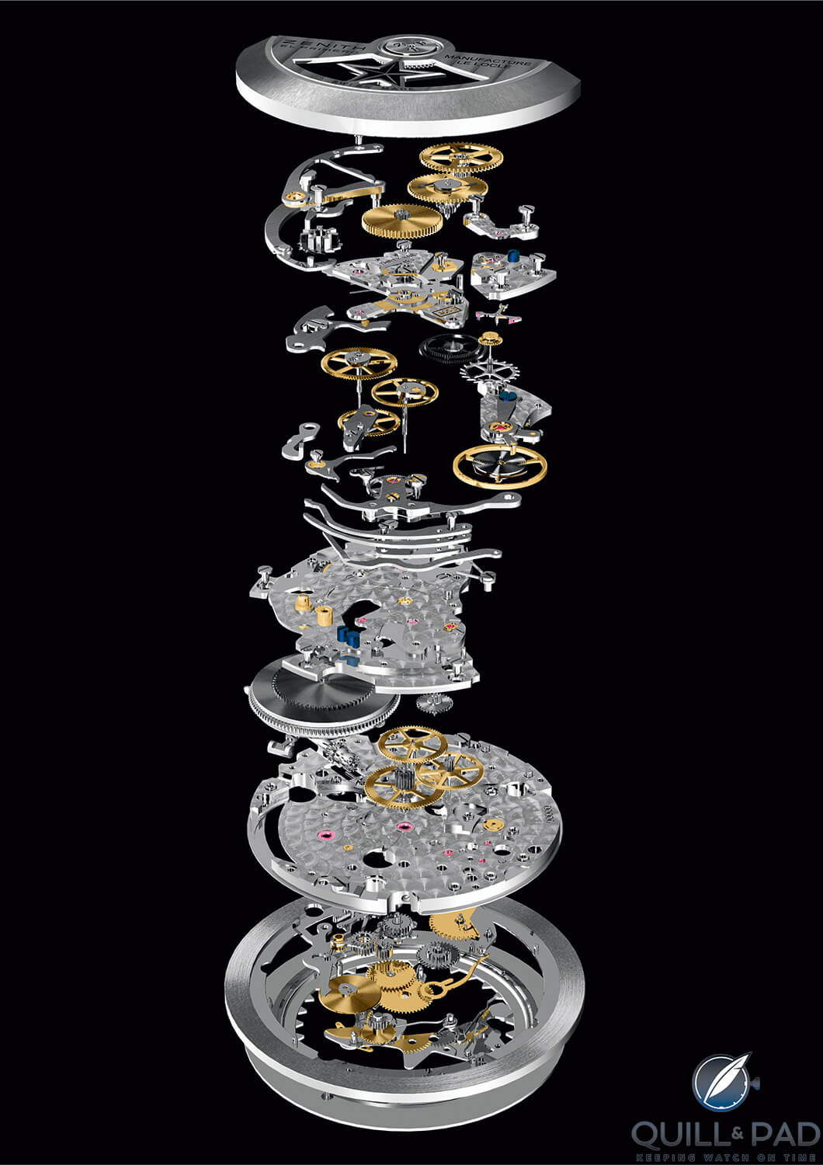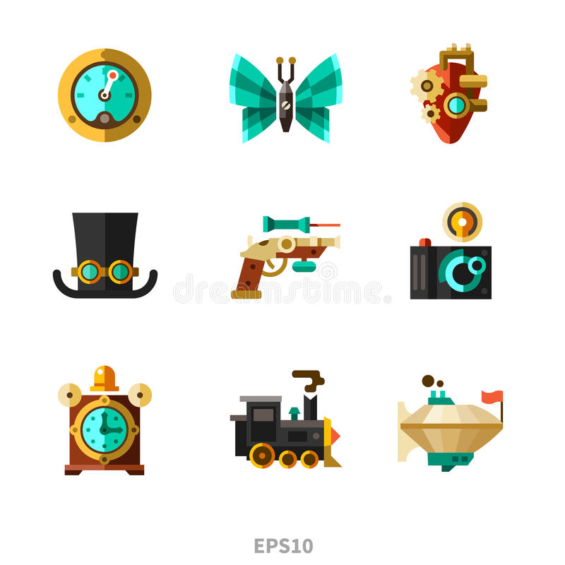

# 

# Tech

We are using the Unity game engine for the game.

Are you using any plug-ins or packages?

Are there any technical considerations, requirements, or constraints?

# Audio

SATISFYING

What is the game’s audio direction?

Are there any audio considerations, requirements, or constraints?

# UI

There is no need to display lives, score or time, so the UI can be effectively neglected during gameplay.

On the Main and Pause menus, UI should be minimal and straightforward.

What style will the UI be?

What UI elements will be needed in the game?

What information must be relayed to the player?